1 City Walk
Leeds, West Yorkshire LS11 9DX
United Kingdom
T +44 (0)113 242 6771
F +44 (0)113 389 1389
 |  | www.jacobs.com
Subject | North Blackburn Scheme | Project Name TfL Major Schemes Programme
From | Jacobs | Project No. B2327505
Date 18th December 2018

Introduction
Jacobs have undertaken a comprehensive review of the Strategic Outline Business Case (December 2018) produced by Blackburn with Darwen Borough Council (BwDBC) in support of the North Blackburn Growth Deal 3 Scheme.
The review findings should be used to inform a recommendation on whether the scheme should be granted Full Approval status at the next LEP Board meeting.

Methodology
The Strategic Outline Business Case has been reviewed and assessed against the Department for Transport’s (DfT) guidance on Transport Business Cases (January 2013). This approach shows whether schemes:
- are supported by a robust case for change that fits with wider public policy objectives – the ‘strategic case’;
- demonstrate value for money – the ‘economic case’;
- are commercially viable – the ‘commercial case’;
- are financially affordable – the ‘financial case’; and
- are achievable – the ‘management case’.
A Red-Amber-Green (RAG) assessment has been undertaken on each of the five cases in order to:
- Highlight any keys risks associated with the successful delivery of the project in accordance with the Lancashire Enterprise Partnership’s Accountability Framework.
- Identify any areas of the Strategic Outline Business Case where there is insufficient evidence to demonstrate that the scheme has followed DfT best practice for the development of a major scheme.
- Ensure the scheme aligns positively with the LEP’s Strategic Economic Plan.
The completed RAG assessment has been appended to this document as Annex A.
As part of the review process, Jacobs have actively engaged with the scheme promoter (Blackburn with Darwen Borough Council) and their consultants (Capita) in order to seek clarification on any key issues associated with the Strategic Outline Business Case. The RAG assessment summarises the iterative process which has been adopted to update the Strategic Outline Business Case to ensure that it is compliant with the LEP’s Accountability Framework and DfT best practice guidance.
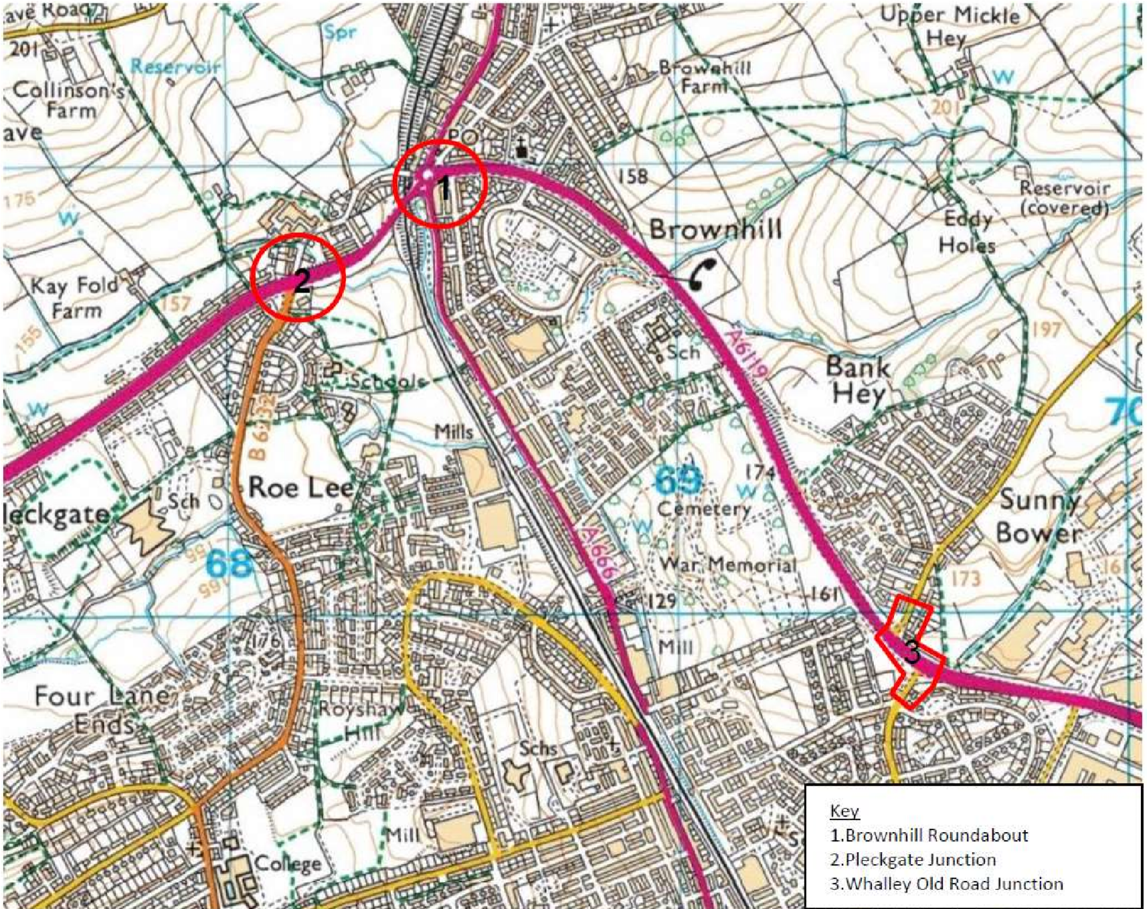

Scheme Description

The North Blackburn Growth Deal 3 scheme involves a trio of civil engineering packages to
upgrade and improve a series of junctions on the A6119 North of Blackburn with modern intelligent
traffic signal equipment, along with resurfacing and associated alterations to road markings,
signage and geometry. The junctions in question are;
1
. the A6119 Brownhill Drive/A6119 Ramsgreave Drive/A666 Whalley New Road/Pleckgate
Road five-arm signalised roundabout junction (the “Brownhill Roundabout”);
2
. the Pleckgate Road/Ramsgreave Drive four-arm signalised junction (the “Pleckgate
junction”), and;
3
. the A6119 Brownhill Drive/A6119 Whitebirk Drive/Whalley Old Road staggered signalised
junction (the “Whalley Old Road junction”)
All junctions will receive upgrades to new signal controller equipment, sustainable transport
improvements for walking and cycling, junction profiling, alignment and infrastructure, associated
highway signage, street lighting, drainage, surfacing, lining and soft/hard landscaping. There is
also a potential to include ducting for future variable message signs (VMS). The scheme is
promoted by Blackburn with Darwen Borough Council (BwDBC). The scheme is one of three being
progressed as part of the “Pennine Gateway” corridor improvements.

Assurance Timeline
- August 2018 – Initial meeting between Jacobs, BwDBC and Capita.
- 12th October 2018 – First full suite of SOBC documents received.
- 31st October 2018 – Initial RAG assessment produced by Jacobs and issued to BwDBC & Capita.
- November / December 2018 – A period of engagement took place between Jacobs, BwDBC and Capita to address the issues identified in the initial RAG assessment.
- 16th January 2019 – TfL board meeting at which the scheme is seeking a funding recommendation.
- Date TBC – next LEP board meeting where the scheme will seek approval for a written decision.

Issues to Note
As outlined above, through a period of engagement between Jacobs, BwDBC and Capita, all of the key issues which were originally identified in the RAG assessment have now been resolved.
However, there are a couple of sections in the SOBC where we feel the evidence could be stronger. Whilst we don’t expect these issues to impact the decision on whether to grant funding approval for the scheme (or necessitate further updates to the SOBC), we are flagging them in our assurance report for completeness.
Further detail is included in our RAG assessment, but in summary the two areas are:
- Traffic modelling
The traffic modelling undertaken is restricted in its scope to only involve junction-level modelling of the scheme area and does not include modelling of the wider transport network.
Whilst we acknowledge that a proportionate approach has been adopted, the following issues were identified within the traffic modelling;
  - A fixed-demand has been assumed in the modelling, with no consideration of demand switching to alternate routes in the Do Minimum scenario / being drawn from alternate routes in the Do Something scenario.
  - No consideration of demand suppression in the Do Minimum scenario / demand induction in the Do Something scenario or changes in peak profile.
Due to the extent of the significant change in delay predicted by the model relative to present conditions, it is possible that the traffic modelling results overstate the travel time benefits to users.
Given the limited availability of data to inform the assessment, and the small scope of the scheme and the need to avoid significant additional work, we have chosen to take a conservative view of the potential scheme benefits by placing greater emphasis on the no-growth and low-growth sensitivity tests reported in the SOBC. These sensitivity tests modelled a lower level of demand growth (no growth after 2019 and a reduced level of growth respectively). These sensitivity tests should therefore be used to inform the overall VfM categorisation to ensure a more conservative approach is adopted.
- Preferred Option Selection
The selection of the preferred option and its scoring against the alternative shortlisted options is an issue which has been discussed at length during the assurance process.
The preferred option reported in the SOBC is understood to represent a low-cost alternative to the best-performing option (due in part to affordability issues).
The traffic modelling results show that the preferred option will be over-capacity by the design year in the core scenario, with levels of delay in excess of what is presently experienced (thus justifying the need for intervention). Additionally, we note that the core scenario does not include the anticipated 4,000 homes to be allocated in NE Blackburn as part of the emerging Local Plan.
It is therefore likely that further intervention may be required at some point in the future. However, it is clear that the preferred option still offers significant benefits over a Do Nothing approach and furthermore should help attract further development in the area (which could in itself be a potential funding source for further improvements).
Key Points
Scheme Cost - The total investment cost is £2.6m, including £0.4m risk.
Programme – Construction work is due to start in late January 2019 and complete by late November 2019.
Funding – BwDBC have stated they will commit to funding the balance between the allocated Growth Deal funding (£2.3m) and the scheme cost (£2.6m) and any cost overruns. A copy of BwDBC’s Section 151 Officer letter is included in Annex B.
Scheme BCR - The Economic Case for the scheme is strong, with the analysis presented showing that the scheme has a core Benefit to Cost Ratio (BCR) of 7.9 (representing ‘Very High’ value for money under DfT classifications for transport schemes). As outlined in the traffic modelling section above, low traffic growth sensitivity tests result in the scheme BCR dropping to between 3.7 and 6.0 (which still represents ‘High’ and ‘Very High’ value for money respectively).
GVA Benefits – The Economic Case identifies two developments sites which are dependent on the North Blackburn scheme. These 2 sites would unlock 427 houses, comprising 272 houses at the North Blackburn Development (Wainhomes Development) site and 155 houses at the Roe Lee (Persimmon Homes) site. The associated GVA assessment forecasts these two sites will generate £17m of net GVA benefits for the local economy over the 60-year appraisal period.

LEP Economic Outputs

The North Blackburn scheme was submitted as part of the wider Pennine Gateway Project, for which BwDBC sought to receive Growth Deal funding.

A comparison of the North Blackburn scheme’s forecast economic outputs, compared against the total expected for the Pennine Gateway project and those reported in the SOBC for the Furthergate scheme, is provided in Table 1. Further information contained within Annex C.

In addition, Annex D contains a copy of the Planning Application Report for the Persimmon Development and Annex E contains a letter from BwDBC in relation to the Wainhomes Development. Both of these documents provide sound evidence to demonstrate that these two developments sites (which form the basis for the reported economic outputs and GVA assessment) can be considered ‘dependent’ on the North Blackburn scheme.

Table 1 - Economic Output Comparison

Economic Output | North Blackburn | Furthergate | Pennine Gateway Forecast Total
Housing units | 427 | Nil | 870
Private sector investment | - | £40m | £125m
Jobs | - | 438 | 3,750
Commercial floor space | - | 17,500 m² | 64,000 m²
GVA | £17m | £236m | £414.7m
Annual cumulative totals of these economic outputs are provided in Table 2.

Table 2 – North Blackburn Annual Economic Output

Year |  | Houses |  | GVA
 | Scheme Dependent | Accelerated | TOTAL
2021 | - | - | - | £0
2025 | 427 | - | 427 | £2,857,121
2026 | 427 | - | 427 | £3,833,836
2027 | 427 | - | 427 | £4,777,522

Conclusions
Following our review of the SOBC for the North Blackburn scheme, it is our view that the scheme should be granted ‘Full Approval’ status, to enable construction to begin in late January 2019.

Appendices
Annex A - RAG Assessment
Annex B - Section 151 Officer Letter
Annex C - Economic Outputs Assessment (included below)
Annex D - Planning Application Report for the Persimmon Development
Annex E - Letter from BwDBC in relation to the Wainhomes Development

